Model Development Phase Template

Date | 19 feb 2026
Team ID | LTVIP2026TMIDS66155
Project Title | Dog Breed Identification using Transfer Learning
Maximum Marks | 10 Marks

Initial Model Training Code, Model Validation and Evaluation Report
The initial model training code will be showcased in the future through a screenshot. The model validation and evaluation report will include a summary and training and validation performance metrics for multiple models, presented through respective screenshots.

Initial Model Training Code (5 marks):

Model Validation and Evaluation Report (5 marks):

Model | Summary | Training and Validation Performance Metrics
Model 1 | 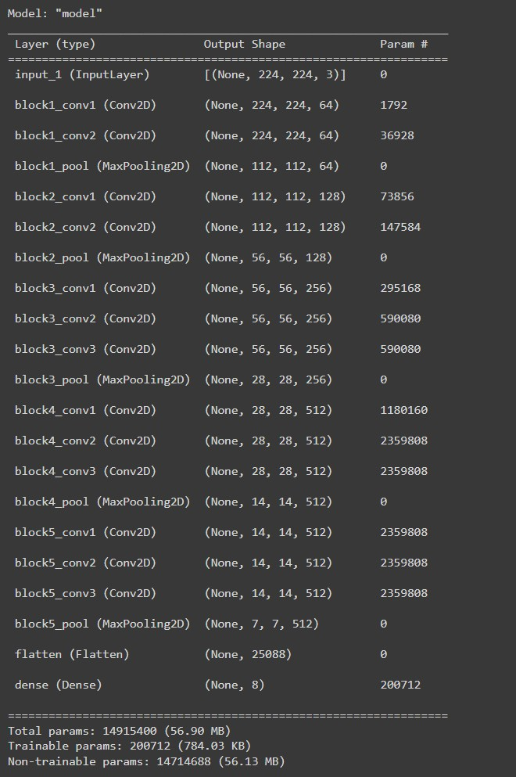 | 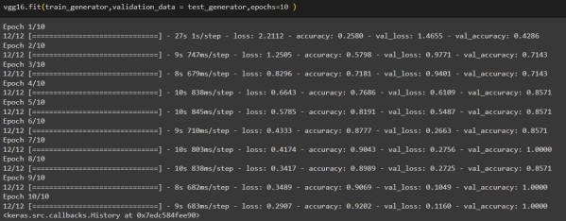
Model 2 | 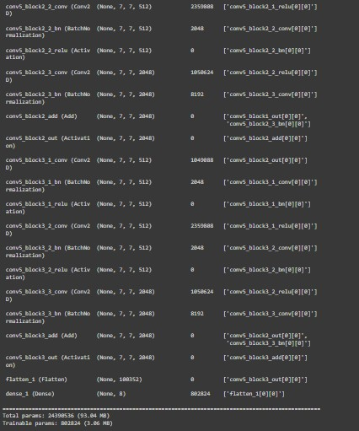 | 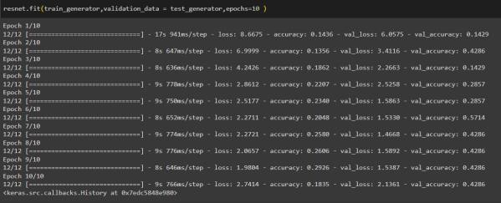

Model 3 | 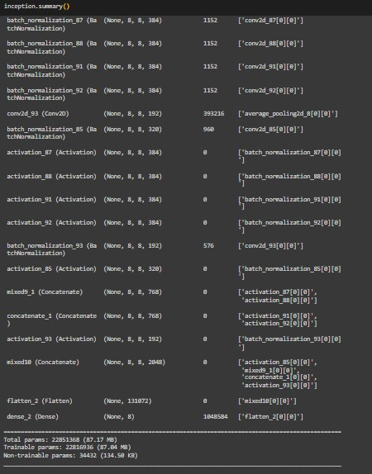 | …  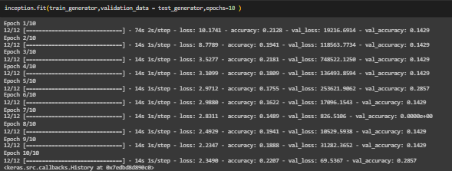
Model 4 | 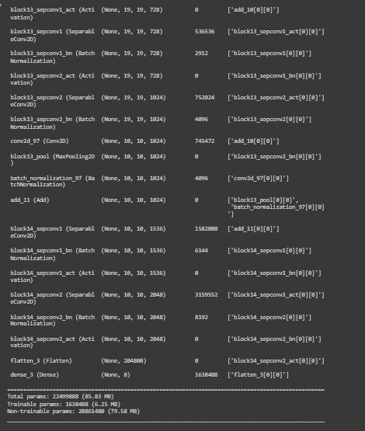 | 